/* A simple rule to estimate your ideal body weight is to allow 110 pounds
for the first 5 feet of height and 5 pounds for each additional inch.
Write a program with a variable for the height of a person in feet
and another variable for the additional inches. Assume the person
is at least 5 feet tall. For example, a person that is 6 feet and
3 inches tall would be represented with a variable that stores the
number 6 and another variable that stores the number 3. Based on
these values, calculate and output the ideal body weight. */

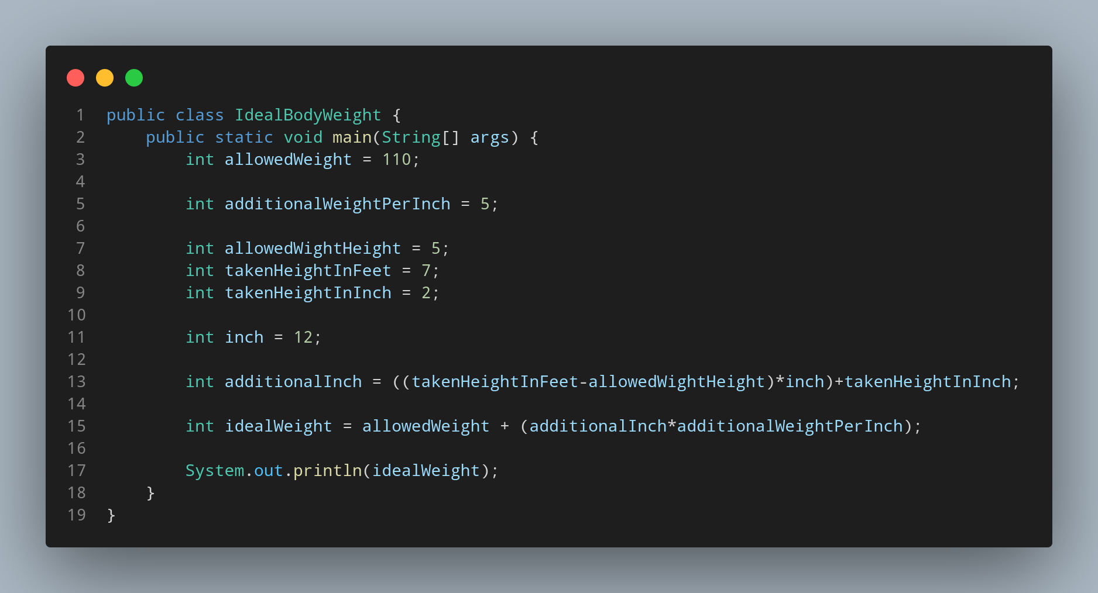

#Doc

File name IdealBodyWeight is created so we create a class name IdealBodyWeight, inside the class we created a main function. Its time to create our variable for weight we have given (allowedWeight is created) for 110 pound. Again variable for height we were given (allowedHeight is created) for 5 inch. We created another variable for storing the given data for increase in weight per every inch named as additionalWeightPerInch. Now from our side we create lets create two variable to store our height of man in term of feet and inch named takenHeightInFeet and takenHeightInInch. We created another variable for amount of inch in a feet as inch
storing value 12 as we know 1 feet = 12 inch . Inside our additionalInch variable we calculated remaining height to increase weight as we were fix with some weight and height. We substracted our total height with our fixed height to find how much inch is remaining. To find idealweight we created a variable named idealWeight that calculate our idea weight according to our height.

Then we print our stored data with a appropriate message.

